ST CLAIR VOLLEYBALL CLASSIC
October 12th, 2019
RED Pool: St. Clair, Warrenton, Cuba, Union, ( HS Gym)
GRAY Pool: Pacific, Orchard Farm, St. James, Grandview (Murray Gym)
Format: The RED Pool will play 2 sets to 25 starting at 4. The GRAY Pool with play 2 sets to 25 starting at 4. Following pool play, the teams will be seeded in a single elimination bracket based on: 1.) record 2.) head-to-head result 3.) point differential for all pool play games 4.) coin toss. For bracket play, scoring will be two out of three to 25 starting at 0. Bracket play will begin immediately following pool play.
Warm-Ups: Each first match of the day warm up will follow MSHSAA volleyball rules. Following, each team will have 4 minutes to warm up. Volleyballs will be furnished, please keep them in the gym.
EACH TEAM MUST SUPPLY ONE LINE JUDGE!
Awards: Plaques will be given to the 1st and 2nd place teams with the champions also receiving individuals medals.
ALL TOURNAMENT TEAM: All tournament team to be selected by Coaches. Certificates will be given at the end of the day.
Officials: We will have two in each gym.
Hospitality Room: There will be a hospitality room for administration, coaches, and bus drivers in the HS Home Ec room.
Entry Fee: Please send $250 to Brian Robbins, St. Clair H.S., 1015 High School Drive, St. Clair, MO 63077. Please make checks out to STC Athletic Department. Please email roster to Becky Branscum at bbranscum@stcmo.org as soon as possible. We will have medical personnel on site that will travel back and forth between the two gyms. Water will be provided in all gyms. No locker room will be provided.
Games will be played as courts become available.
POOL PLAY SCHEDULE
 | High School |  | Edgar Murray
8:00 | St. Clair v Cuba | 8:00 | Pacific v St. James
8:45 | Union v Warrenton | 8:45 | Grandview v Orchard Farm
9:30 | St. Clair v Warrenton | 9:30 | Pacific v Orchard Farm
10:15 | Cuba v Union | 10:15 | St. James v Grandview
11:00 | Union v St. Clair | 11:00 | Grandview v Pacific
11:45 | Warrenton v Cuba | 11:45 | Orchard Farm v St. James
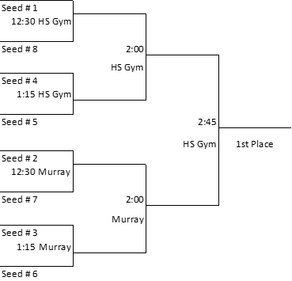

BRACKET PLAY SCHEDULE

